

**Trending videos on YouTube … What success really mean?**

The domain [www.youtube.com](http://www.youtube.com) was created on February 2005, on October 2006 was announced that YouTube would be purchased by Google and at this moment YouTube is the world’s second largest search engine, allowing users to upload, view, rate and share videos, also is the third most visited site after Google and Facebook. To provide answers about YouTube trending videos, we will be working with:

* Dataset from Kaggles.
* Pandas: to clean and format our data set.
* Jupyter Notebook: exploration and data analysis.
* Matplotlib: to create visualizations of the data.
* API: provided by YouTube for the video categories.

***Is better to have more views or being trending more days?***

Between having more views or being more days as trending video in the top 200 list there’s no visual relation or trend that can be extracted.

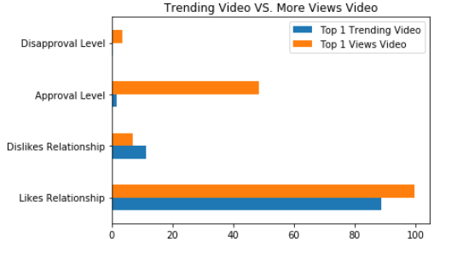

***Does the channel influence the number of views on a video?***

The channel with greater number of trending videos in the sample is ESPN, followed by The Ellen Show.

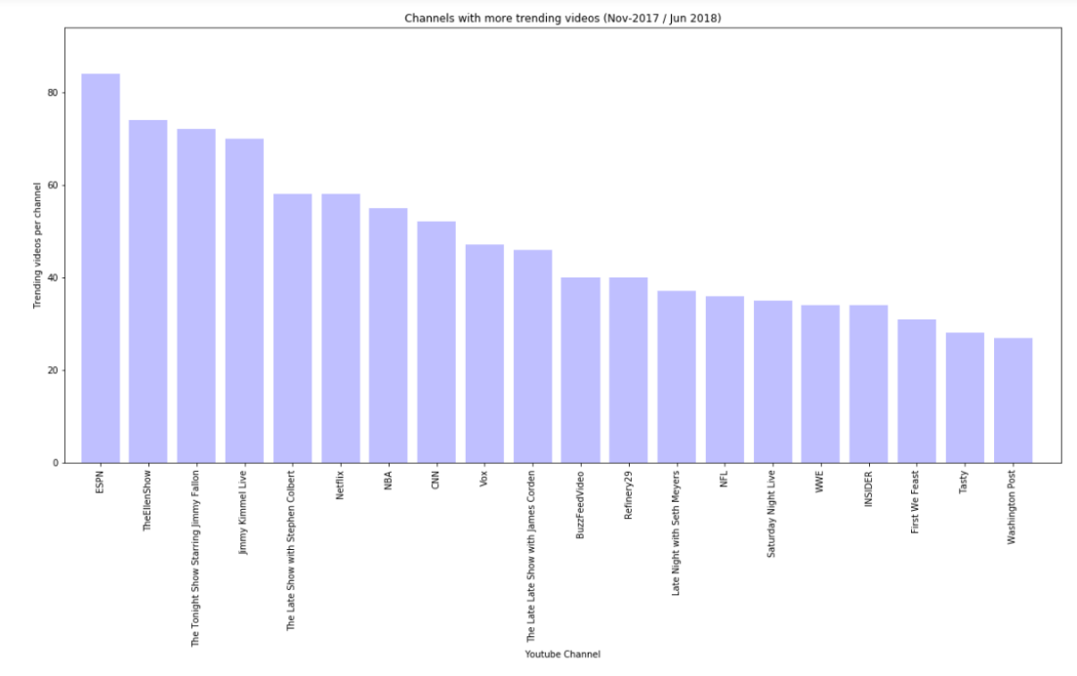

The channel with more number of views is *Childish Gambino VEVO*, followed by YoutuBe Spotlight. ESPN and The Ellen are not even in the 15 more viewed channels.

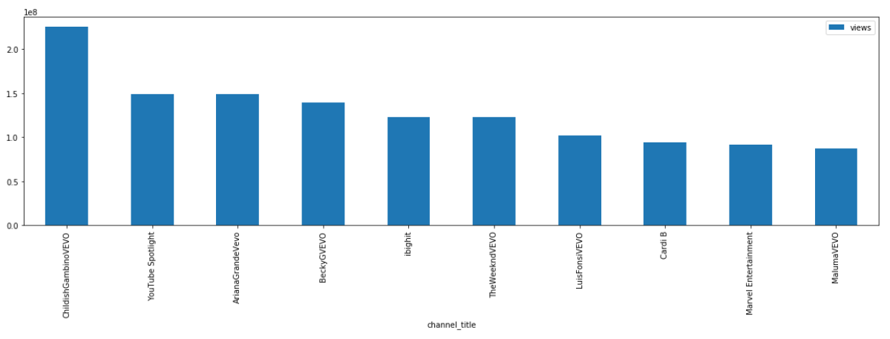

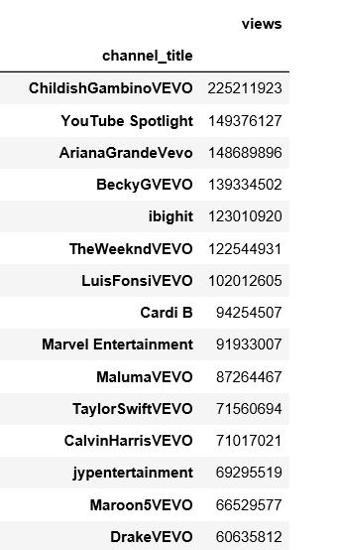

Note that *Childish Gambino VEVO* only have one trending video, and the views were higher than the sum of the rest of views of trending videos per channels.

Now if we add these two scopes for a channel in one scatter plot, we have the following chart:

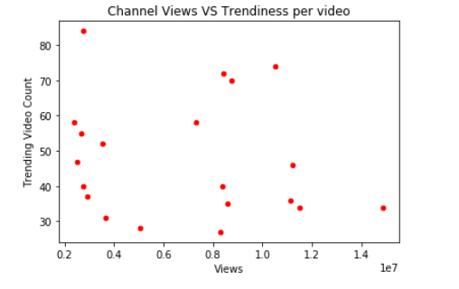

So we cannot derive a direct relationship between trending Channel and views

***Does the category influence the quantity of views?***

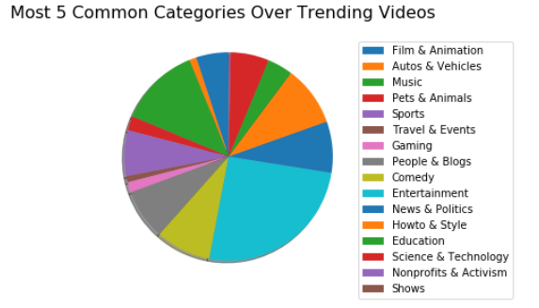

The category with a greater number of views is Entertainment, followed by Music. This can be explained because Music for example, is a category where you can want to listen/view the video 10 times per week, and tis not necessarily means that will put the video on the trending chart.

**Having a Controversial Video Determines the Amount of Visualizations?**

**Chi-square Independence Test**

Hypothesis to evaluate (Null Hypothesis):

“There is no statistically significant relationship between controversiality and the number of views per video. “

Controversial: Video with more than 3,000 likes.

Success: get more views per video.

Trending: To be located at least one day on the 200 top view videos daily

High view: Video with more than 2,000,000

**Having a Controversial Video Determines the Amount of Visualizations?**

**Chi-square Independence Test**

**Alternative hypothesis**

H1: There is a statistically significant relationship between dislikes and the number of views per video.

Table

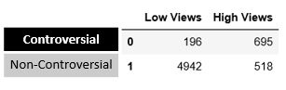

Results



Analysis

* Expected frequencies > 5 : thus, the chi-square test can be trusted
* P-value < 0.05: reject null hypothesis
* The result indicates **that there is a relationship between Views and Dislikes** ….

**Final Conclusions**

* The more days trending video “We Made Our Mama Cry“(j4KvrAUjn6c) was trending for 30 days and got 10,381,263 views
  + That represents only 4.6% of views respect the video that got more views during the same period
  + likes: 163,325 Dislikes: 20,892 comments: 25,323
* The video with more views: “Childish Gambino“(VYOjWnS4cMY) was trending 25 days and got 225,211,923 views
  + # likes: 5,023,450 Dislikes: 343,541 comments: 517,232
* Channel with more trending videos was ESPN with 85 trending videos during the same period, this volume represents the 8% of the total trending videos studied
* The category with more trending videos was #24: Entertainment, and represents the 25% of the trending videos
* Based on Chi-square independence test exist a significant relation between dislikes and times of views!

**Ideas for future researches:**

* Evaluate the chi square by category.
* Try to find a relation between tags and # of views.
* Get a dataset with the information of the complete videos uploaded during a year and find relations over which get trending and which not.
* Is there any tendency to watch more YouTube videos during a specific season?
* The trending videos over the USA has the same tendency over other countries during the same period?